Van Genuchten model

In a multiphase system, a fundamental correlation between the wetting and the non-wetting phase saturation and the capillary pressure exists. An increase of the saturation of the saturation of the non-wetting phase must also lead to an increase of the capillary pressure. If the saturation of the wetting phase decreases, the wetting fluid retreats to smaller pores or fracture apertures.

Thus, the macroscopic consideration of the capillary results in the following capillary pressure-saturation relation:

p_{c} = p_{c}(S_{w})

An analytical determination of the capillary pressure-saturation relation for porous and fractured porous media is impossible because of the irregular pore geometry (fracture geometry). Therefore, a large number of scientists have already tried to derive a functional correlation between capillary pressure and saturation. Among those of many other scientists, the most famous models are models of air-water system by Leverett (1941), Brook and Corey (1964) and Van Genuchten (1980).

These models contain parameters which try to account for the different pore space geometry, for example the pore size distribution and the interconnectivity of the pore space. Usually, they are used in order to fit the models to the experimental data.

The COLOMBO model uses the following correlation for a two-phase gas-water system by Van Genuchten:

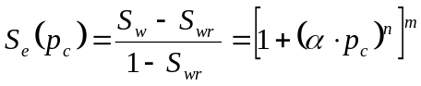 for p_{c} > 0

where S_{e} is the effective saturation, S_{wr} is the residual water saturation and n, m and α (Pa⁻¹) are the Van Genuchten parameters.

The capillary pressure is often formulated as a function of the effective saturation. We get:

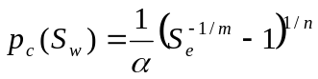 for p_{c} > 0

In a three-phase system, few investigations of the capillary pressure-saturation relation have been carried out, because of the difficulties associated with the experiments in such complex systems. The initial results from three-phase experiments confirm the popular approach to describe the capillary pressure-saturation behavior of a three-phase system by a combination of the capillary pressure-saturation functions of two-phase system.

